## Login page:

User can login as normal user or admin user

Admin login will redirect to user manage page

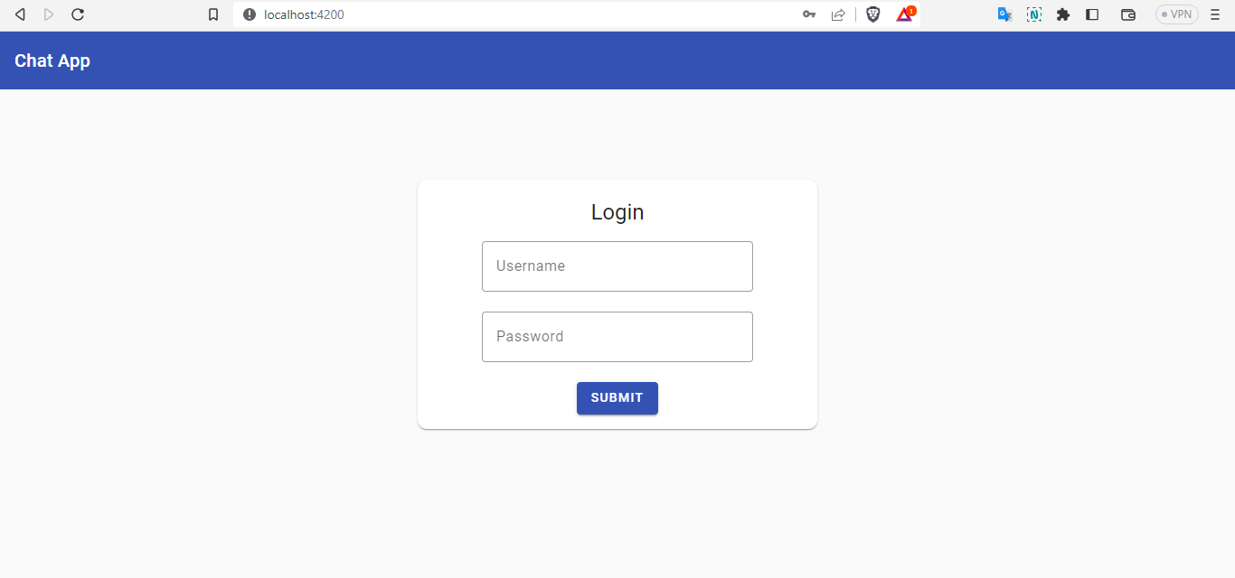

## Menu:

Side menu for admin it will show home and admin items.

For normal user it will show only Home.

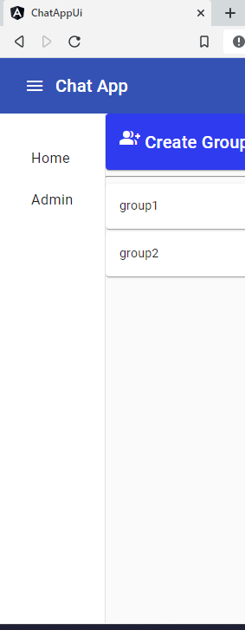

## Toolbar

Tool bar will show logout and side menu button after login.

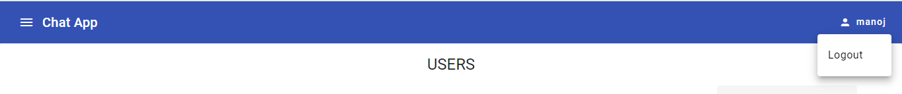

## Home:

Home page show Groups, messages, create group option for all users.

In Right side it show selected group and its messages. Other users messages will shows left side and if logged in users message will show in right side.

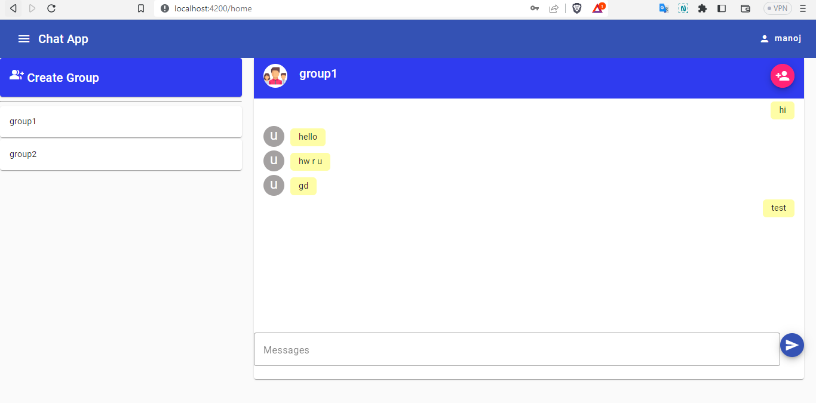

Left side when you click on the create group button it will show input option to enter the group name. We can enter name and create group. Admin tfor this created group is the one who created.

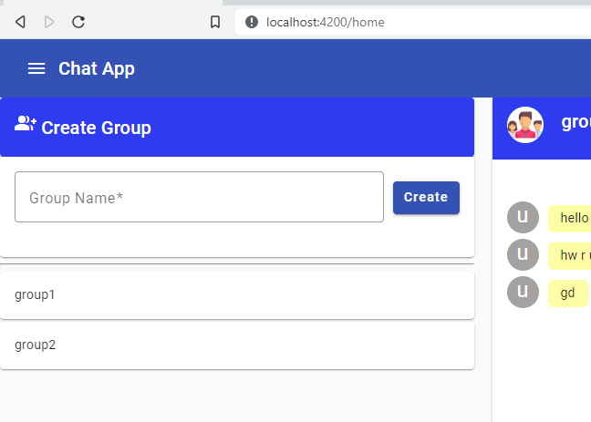

Right side We have this add user to the group option. When u click on it it will show the list of user available and already users added to the group will be check marked. We can add or remove the user from the group.

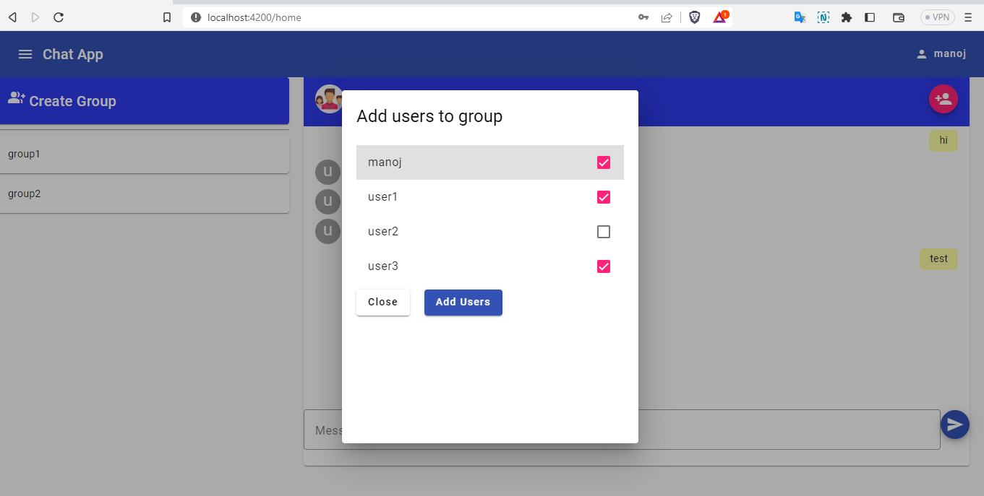

## Manage user page:

Only admin have the access to this page user can be created, deleted, and modify by the admin.

